Algebra – Review Unit 2 Summative Name:

Solve Equations
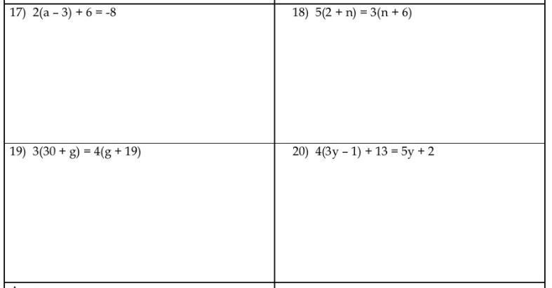
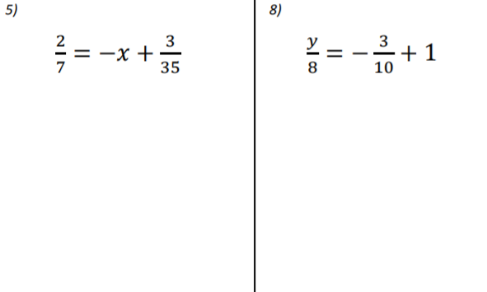
Solve Inequalities:
Corrections on Formative 2
Solve Absolute Value Equations/ Inequalities
$|5x+5|+22=57$ $|7x|-3 >25$

$2|2x+8| >12$ $3|x+4|-8 <1$ $|2x+8|≥6$

Word Problems
- Jon won 40 lollipops playing basketball at the school fair. He gave two to every student in his math class. He has 8 lollipops left. Find the number of students in his class.

- Jacob spent less than $26 on a magazine and 3 composition notebooks. The magazine cost $5. What was the cost of each composition notebook.

- Angela rented a bike from Sasha’s bikes. They charged her $2 per hour, plus a $8 fee. Angela only has $25, how long can she ride the bike?

- Currently, you have $80 and your sister has $140 in your piggy banks. You both get an allowance of $10 each week. You decide to save $5 of your allowance each week, while your sister decides to spend her whole allowance plus $10 each week. How long will it be before you have as much money as your sister?

