Geometry – Homework Name:

Unit 4- Transformations Period: 2 4 7 Date: 1/12/18

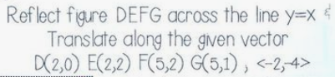
Fill in the missing notation for each coordinate change based on the transformations described and graphed:

$DEFG$ to $D^{'}E^{'}F^{'}G^{'}: \left(x,y\right)→\left( , \right)$

$D'E'F'G$’ to $D^{''}E^{''}F^{''}G^{''}: \left( , \right)→\left( , \right)$

$DEFG$ to $D^{''}E^{''}F^{''}G^{''}: \left(x,y\right)→\left( , \right)$

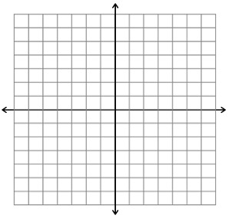

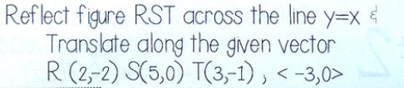

Fill in the missing notation for each coordinate change based on the transformations described and graphed:

$$RST to R'S'T' \left(x,y\right)→\left( , \right)$$

$$R'S'T' to R''S''T'' : \left( , \right)→\left( , \right)$$

$$RST to R^{''}S^{''}T^{''}: \left(x,y\right)→\left( , \right)$$

Geometry – Discovery Activity Name:

Unit 4- Transformations Period: 2 4 7 Date: 1/12/18

- Reflect the following triangle across the line $y=-1$ to create $T_{2}.$ Then, reflect $T_{2}$ over the line $y=2$.

- Write a rule for the Reflections described above.

- Look at the transformation from $T_{1}$ to $T_{3}$. Write the transformation by writing the rule using a translation.

- Reflect the following triangle across the $y-axis$ to create $T_{2}.$ Then, reflect $T_{2}$ over the line $x=-2$.

- Write a rule for the Reflections described above.

- Look at the transformation from $T_{1}$ to $T_{3}$. Write the transformation by writing the rule using a translation.

Generalization:

