2. Ms. Brauer starts out for school at 5:30 AM and drives 10 miles in 15 min. She then stops for 30 minutes at Dunkin Donuts for a coffee. Afraid that she might be late for school, she continues driving a little faster for another 20 minutes and covers 18 miles at which point her car breaks down. From that point, she jogged the remaining 3 miles to school in 45 minutes.

Draw a graph with the distance on the vertical axis and time on the horizontal axis. (On a seperate sheet of paper)

Then fill out the table below:

Part of Trip | Equation | Domain
Driving Part 1

Dunkin Donuts Stop

Fast Driving

Jogging

What time will she arrive at school?

2. Ms. Brauer starts out for school at 5:30 AM and drives 10 miles in 15 min. She then stops for 30 minutes at Dunkin Donuts for a coffee. Afraid that she might be late for school, she continues driving a little faster for another 20 minutes and covers 18 miles at which point her car breaks down. From that point, she jogged the remaining 3 miles to school in 45 minutes.

Draw a graph with the distance on the vertical axis and time on the horizontal axis. (On a seperate sheet of paper)

Then fill out the table below:

Part of Trip | Equation | Domain
Driving Part 1

Dunkin Donuts Stop

Fast Driving

Jogging

What time will she arrive at school?

- Fill in the missing information for the chart.
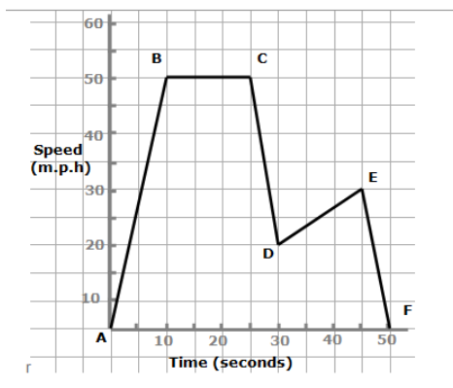
Part of Graph | Equation | Domain
From A to B
From B to C
From C to D
From D to E
From E to F

Fill in the missing information for the chart.
Part of Graph | Equation | Domain
From A to B
From B to C
From C to D
From D to E
From E to F

