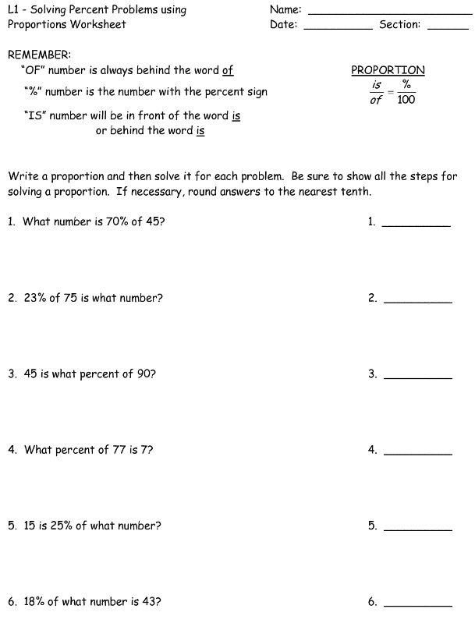 

**We Try:** A student earned a grade of 80% on a math test that had 20 problems. How many problems on this test did the student answer correctly? (round to the nearest whole number)

**You Try:** There are 36 carpenters in a crew. On a certain day, 29 were present. What percent showed up for work? (round to the nearest tenth)

1. A metal bar weighs 8.15 ounces. 93% of the bar is silver. How many ounces of silver are in the bar? (round to the nearest thousandth)

2) A woman put $580 into a savings account for one year. The rate of interest on the account was 6½%. How much was the interest for the year in dollars and cents? (Round to the nearest cent)

**We Try:** A student earned a grade of 80% on a math test that had 20 problems. How many problems on this test did the student answer correctly? (round to the nearest whole number)

**You Try:** There are 36 carpenters in a crew. On a certain day, 29 were present. What percent showed up for work? (round to the nearest tenth)

1. A metal bar weighs 8.15 ounces. 93% of the bar is silver. How many ounces of silver are in the bar? (round to the nearest thousandth)

2) A woman put $580 into a savings account for one year. The rate of interest on the account was 6½%. How much was the interest for the year in dollars and cents? (Round to the nearest cent)