Geometry – Mixed Practice Name:

Unit 3- Circles Period: 2 4 7 Date: 11/29/17

Warm-up:
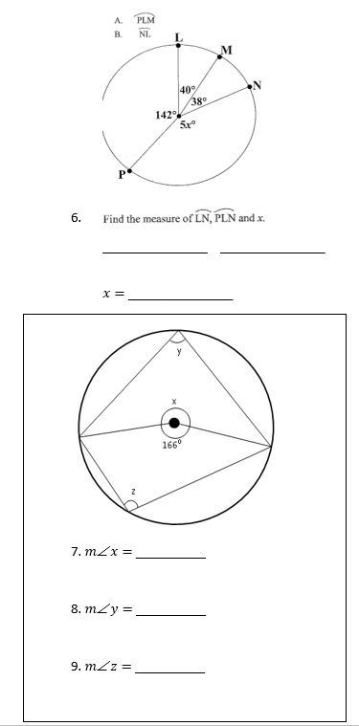
$mx=$______________
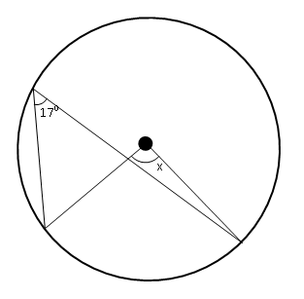

- $m x=$__________
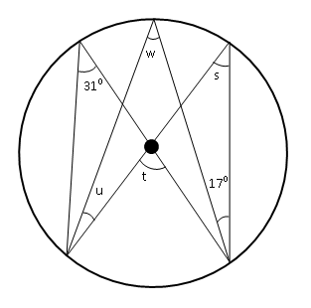

2. $m w=$__________

3. $m s=$__________

4. $m u=$__________

5. $m t=$__________

