Algebra 1– HW Name:

Unit 3- Linear Equations Period: 3 8 Date: 12/11/17

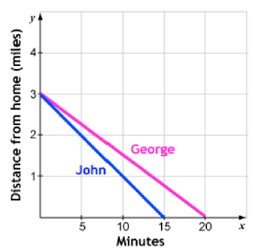
- George and his brother John rode their bikes home from a park. The graph shows each rider’s distance from home over a period of time. What explains the difference in the slopes of these two graphs?

  - John traveled a greater distance.
  - George traveled a greater distance.
  - George rode his bike slower.
  - John rode his bike slower.

Explain: ________________________________________________

- Find the equation/ graph for each situation.
- What is the equation of the line graphed here?  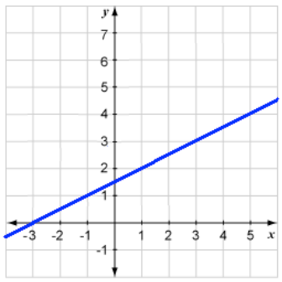 | - What is the graph of the line associated with the equation 3x – 5y = 30 ?
- When a graph is created from the table shown, what is the graph of the line?  x -4 -2 0 2 4 6 8  y -2 0 2 4 8 10 12 | - What is the equation of the line that passes through the points (4,3) and  (9, 14)?

