Algebra 1 – Homework Name:

Unit 3- Graphing Period: 3 8 Date: 12/6/17

Find the slope and y-intercept of each graph. Use them to write the equation of the line.

- $Equation: ______________________$ 2. $Equation: ______________________$ 3. $Equation: ______________________$

- $Equation: ______________________$ 5. $Equation: ______________________$ 6. $Equation: ______________________$

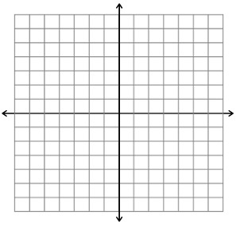
Graph the following equations on the graph to the right.
Label each line accordingly.

$$Line 1: y=\frac{3}{2}x+2$$

$Line 2: y=-4$

$$Line 3: x=3$$

$$Line 4: y=-2x+5$$

