Geometry – Review Name:

Unit 3- Arc Length and Sector Area Period: 2 4 7 Date: 12/14/17

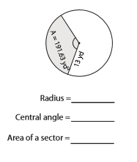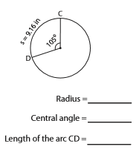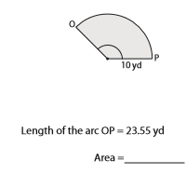

Geometry – Review Name:

Unit 3- Arc Length and Sector Area Period: 2 4 7 Date: 12/14/17

