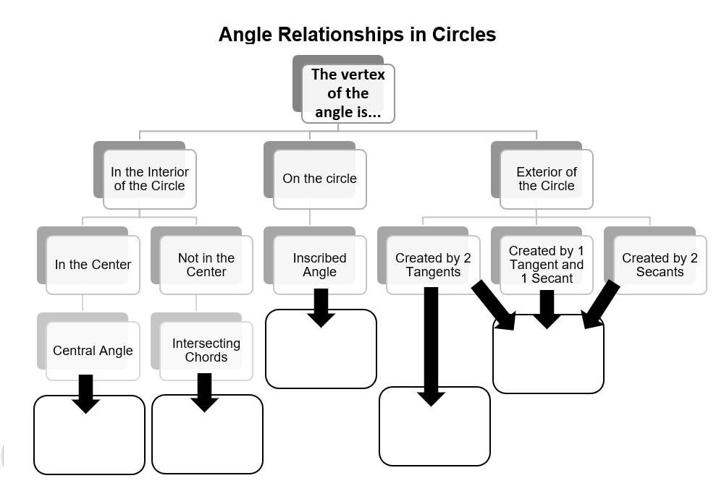



|  |  |  |
| --- | --- | --- |
|  |  | : |
|  |  |

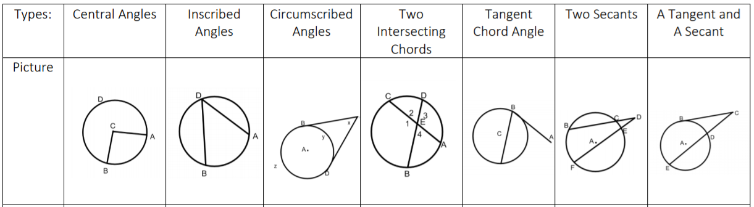

Two Tangents

|  |  |  |
| --- | --- | --- |
| $$Circumference of Circle=2πr$$ | $$Arc Length= \frac{x}{360}∙2πr$$ | $Equation of a Circle$: $${(x-h)}^{2}+{(y-h)}^{2}=r^{2}$$ $$with center at \left(h,k\right) and$$ $$radius, r$$ |
| $$Area of Circle= πr^{2}$$ | $$Area of a Sector= \frac{x}{360}∙πr^{2}$$ |



Two Tangents

**Angle Relationships in Circles**