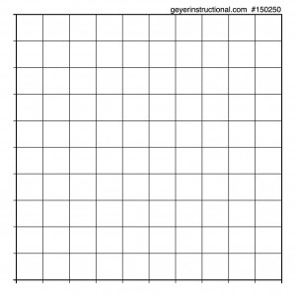
- Olivia is selling chocolate bars to raise money for ROTC. Fill in the remaining information of the table. Graph the information (making sure to label your axis) Determine the cost of each chocolate bar.

x | y
0 | 0
2
4 | 6
5

- Jonathan can make 5 baskets for every 6 baskets that Ms. Brauer makes. If they scored a total of 60 points (2 points per basket). How many did Ms. Brauer score? Jonathan?

- Olivia is selling chocolate bars to raise money for ROTC. Fill in the remaining information of the table. Graph the information (making sure to label your axis) Determine the cost of each chocolate bar.

x | y
0 | 0
2
4 | 6
5

- Jonathan can make 5 baskets for every 6 baskets that Ms. Brauer makes. If they scored a total of 60 points (2 points per basket). How many did Ms. Brauer score? Jonathan?

