**Geometry – In-Class Practice Name:**

**Unit 3- Tangent Lines Period: 2 4 7 Date: 12/4/17**

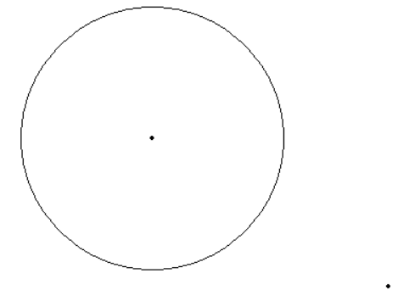

***Directions for Constructing Tangent Lines***

1. Draw a segment from the center of the circle to the point.
2. Create the Perpendicular Bisector of the segment.
3. Create a circle with the center at the midpoint of the line.
4. Draw a line through the original point and through the intersection point created on the circle (X2)





