Geometry – Homework Name:

Unit 3: Circles Period: 2 4 7 Date: 12/8/17

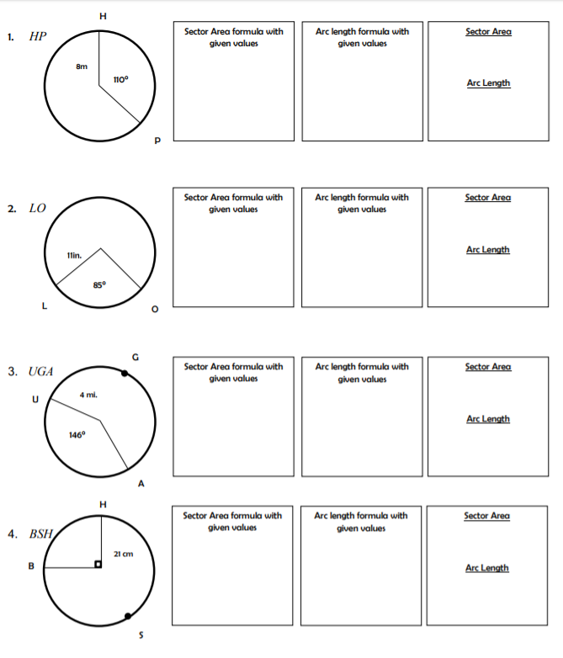

Geometry – Homework Name:

Unit 3: Circles Period: 2 4 7 Date: 12/8/17

