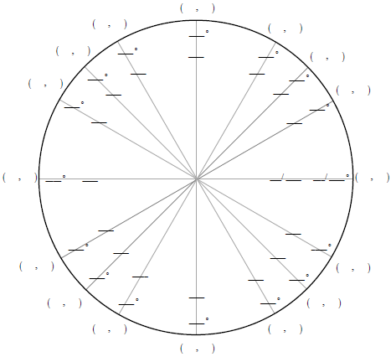

Law of Sines: | Area of a Triangle:
Law of Cosines: | Heron’s Formula:

