Geometry – Discovery Activity Name:

Unit 4- Transformations Period: 2 4 7 Date: 1/16/18

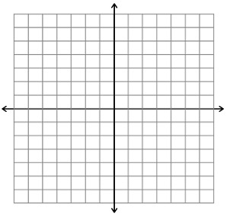
- Trace the arrow and the axis onto your patty paper.
- Make a conjecture. Where do you think the arrow will end up if
you rotate the image 90° about the origin?
____________________________________________________
- Test your conjecture by rotating the image around the origin.
- Make a conjecture. Where do you think the arrow will end up if
you rotate the image 180° about the origin?
____________________________________________________
- Test your conjecture by rotating the image around the origin.
- Make a conjecture. Where do you think the arrow will end up if
you rotate the image 270° about the origin?
____________________________________________________
- Test your conjecture by rotating the image around the origin.

Geometry – Discovery Activity Name:

Unit 4- Transformations Period: 2 4 7 Date: 1/16/18

- Trace the arrow and the axis onto your patty paper.
- Make a conjecture. Where do you think the arrow will end up if
you rotate the image 90° about the origin?
____________________________________________________
- Test your conjecture by rotating the image around the origin.
- Make a conjecture. Where do you think the arrow will end up if
you rotate the image 180° about the origin?
____________________________________________________
- Test your conjecture by rotating the image around the origin.
- Make a conjecture. Where do you think the arrow will end up if
you rotate the image 270° about the origin?
____________________________________________________
- Test your conjecture by rotating the image around the origin.

Geometry – Discovery Activity Name:

Unit 4- Transformations Period: 2 4 7 Date: 1/16/18

- Reflect the following triangle across the line $y=2$ to create $T_{2}.$ Then, reflect $T_{2}$ over the line $y=x$.

- Write a rule for the Reflections described above.

- Look at the transformation from $T_{1}$ to $T_{3}$. What type of transformation does it look like?

Generalization:

Geometry – Discovery Activity Name:

Unit 4- Transformations Period: 2 4 7 Date: 1/16/18

- Reflect the following triangle across the line $y=2$ to create $T_{2}.$ Then, reflect $T_{2}$ over the line $y=x$.

- Write a rule for the Reflections described above.

- Look at the transformation from $T_{1}$ to $T_{3}$. What type of transformation does it look like?

Generalization:

