***Get out a piece of notebook paper and complete the following questions. Organize your work accordingly and raise your hand if you have questions. This worksheet can be found on the blog if you do not finish your work in class.***

1. Use the graph to complete the tasks and answer the questions below.

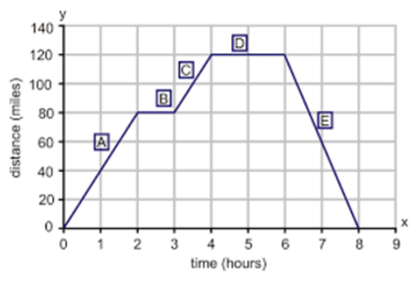

***On your paper create a chart of the following. Then answer the questions below.***

1. Calculate the slope of each interval.
2. Write an equation for each interval.   (in slope-intercept form)
3. State the domain and range for each interval.

|  |  |  |  |  |
| --- | --- | --- | --- | --- |
|  | Slope | Equation | Domain | Range |
| A |  |  |  |  |
| B |  |  |  |  |
| C |  |  |  |  |
| D |  |  |  |  |
| E |  |  |  |  |

1. Is the graph discrete or continuous? Explain.
2. Which intervals have the same rate of change?  How do you know?
3. Which interval represents the greatest rate of change?
4. What is the Domain of the entire graph? The Range?
5. If the graph represents various elevations of a plane over time, write a verbal description that represents this scenario.

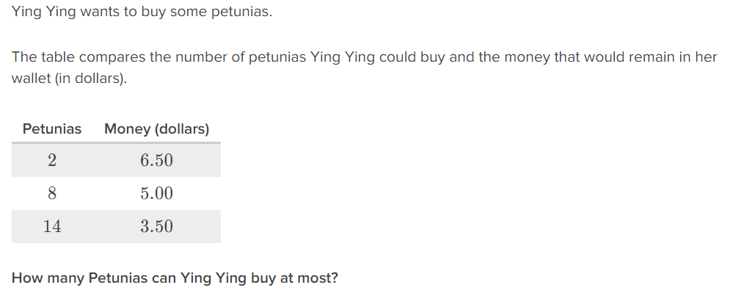

How much does each petunia cost?

What is the y-intercept? What does the y-intercept represent in the context of the situation?

What is the maximum number of petunias she can buy?