**Geometry – In-Class Practice Name:**

**Unit 3- Constructing Circles Period: 2 4 7 Date: 12/13/17**

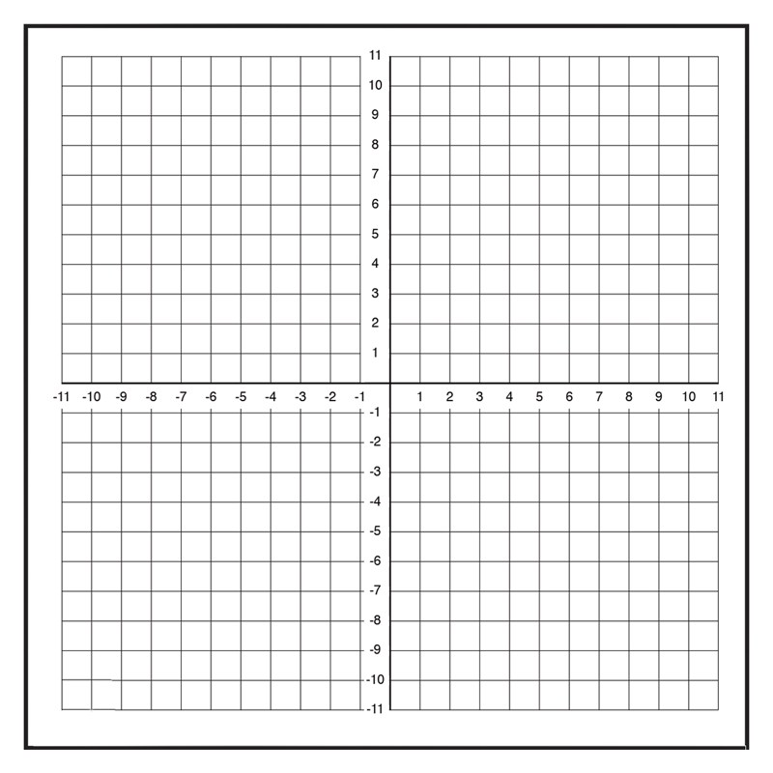

***Directions for Constructing a Circle from 3 pts.***

1. Plot the points.
2. Draw 2 segments using the points given as endpoints.
3. Find the Perpendicular Bisector of each segment.
4. Find the intersection point of the 2 perpendicular bisectors.
5. The intersection pt. is the CENTER of your Circle
6. Draw your circle by placing the point of your compass at the CENTER and the pencil of your compass on one of the original points given.

CHECK: All three original points are ON the circle.

Write an equation for the circle using the following formula:

$${(x-h)}^{2}+{(y-k)}^{2}=r^{2}$$

Where $(h,k)$ is the CENTER and $r$ is the radius of the circle.

|  |  |  |
| --- | --- | --- |
| Center: | Radius: | Equation: |

**Geometry – In-Class Practice Name:**

**Unit 3- Constructing Circles Period: 2 4 7 Date: 12/13/17**



***Directions for Constructing a Circle from 3 pts.***

1. Plot the points.
2. Draw 2 segments using the points given as endpoints.
3. Find the Perpendicular Bisector of each segment.
4. Find the intersection point of the 2 perpendicular bisectors.
5. The intersection pt. is the CENTER of your Circle
6. Draw your circle by placing the point of your compass at the CENTER and the pencil of your compass on one of the original points given.

CHECK: All three original points are ON the circle.

Write an equation for the circle using the following formula:

$${(x-h)}^{2}+{(y-k)}^{2}=r^{2}$$

Where $(h,k)$ is the CENTER and $r$ is the radius of the circle.

|  |  |  |
| --- | --- | --- |
| Center: | Radius: | Equation: |



***Directions for finding the center of any Circle:***

1. Draw three points on the circle.
2. Draw 2 segments using the points drawn as endpoints.
3. Find the Perpendicular Bisector of each segment.
4. Find the intersection point of the 2 perpendicular bisectors.
5. The intersection pt. is the CENTER of your Circle



***Directions for finding the center of any Circle:***

1. Draw three points on the circle.
2. Draw 2 segments using the points drawn as endpoints.
3. Find the Perpendicular Bisector of each segment.
4. Find the intersection point of the 2 perpendicular bisectors.
5. The intersection pt. is the CENTER of your Circle