Station 1
- Understand and use the 6 trigonometric relationships of acute angles in triangles. (13.1)

Directions: Find the sine, cosine, tangent, cosecant, secant, and cotangent of the following angles. Write your answers as reduced fractions.

1.)  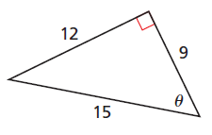 | 2.)  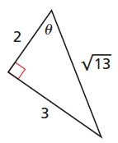 | 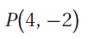  3.)

Station 2
- Determine side lengths of right triangles by using trigonometric functions. (13.1)

4.) 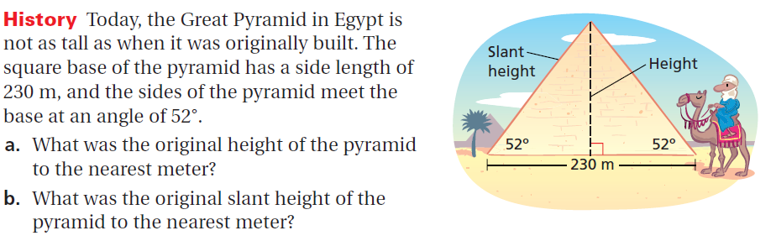
5.) 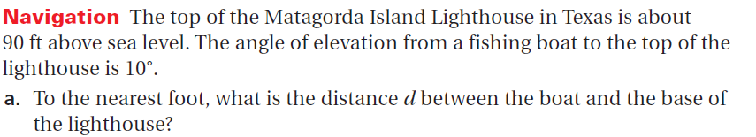

Station 3
- Sketch angles of rotation in standard position. (13.2)

Directions: Sketch the angle of rotation in standard position and demonstrate how to use the unit circle to approximate the $\cos{θ}$.

6.) $θ=$500° | 7.) $θ=$225° | 8.) $θ= π$ radians

Station 4
- Find positive and negative coterminal angles of a given angle. (13.2)

9.)  Define a coterminal angle. | 10.)  $$θ= 115°$$ | 11.)  $$θ= 385°$$ | 12.)  $θ= \frac{2π}{3}$ radians

Station 5
- Convert angle measures between degrees and radians. (13.2)

13.) | 14.) | 15.)

Station 6
- Find the exact values of trigonometric functions on the UNIT CIRCLE. (13.3)

16.) | 17.) | 18.)

Station 7
- Recognize and graph trigonometric functions. (14.1)
- Students will be able to find the domain, range, amplitude, and period of a trigonometric function. (14.1)

Directions: Identify the transformations for each of the following functions. Then graph the function.

19.)  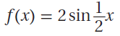 | 20.)  