Geometry – Practice Name:

Unit 3- Arc Length and Sector Area Period: 2 4 7 Date: 12/13/17

USE 3.14 as Pi and SHOW YOUR WORK ON A SEPARATE SHEET OF PAPER
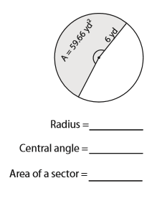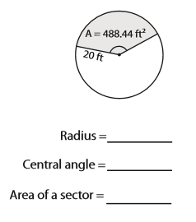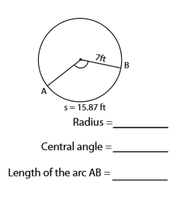

Geometry – Practice Name:

Unit 3- Arc Length and Sector Area Period: 2 4 7 Date: 12/13/17

USE 3.14 as Pi and SHOW YOUR WORK ON A SEPARATE SHEET OF PAPER

USE 3.14 as Pi and SHOW YOUR WORK ON A SEPARATE SHEET OF PAPER

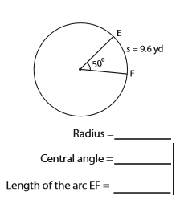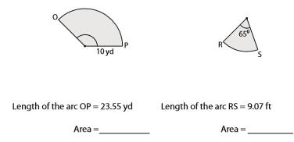

USE 3.14 as Pi and SHOW YOUR WORK ON A SEPARATE SHEET OF PAPER

